Hormonal Control of Reproduction – Notes
- The menstrual and ovarian cycles depend on the endocrine glands for their regulation and control.
- Endocrine glands secrete hormones into extracellular fluid surrounding the cells that make up the gland.
- The secretion then usually passes through the capillaries to be transported via blood.

Reproductive hormones:
Hormone: | Target organ: | Effect of hormone:
Follicle-stimulating hormone (FSH) from | Seminiferous tubules of testes. | Production of sperm.
pituitary gland | Follicles of ovaries. | Maturation of ovarian follicles.
Human chorionic gonadotropin. | Corpus luteum. | Maintenance of corpus luteum during early stages of pregnancy.
Lactogenic hormone (prolactin) from pituitary gland. | Breasts. | Production of milk in activated glands.
Luteinising hormone from pituitary gland. | Interstitial cells of testes. | Stimulates secretion of testosterone.
 | Cells of the ovaries. | Stimulates secretions of oestrogen and progesterone.
Oestrogens from ovarian follicle and corpus luteum. | Various. | Development of female reproductive system.
 |  | Development of secondary sexual characteristics.
Oxytocin from pituitary gland. | Uterus. | Stimulates contraction of smooth muscle.
 | Breasts. | Promotes contraction of muscle cells surrounding breast lobules.
Progesterone from corpus luteum. | Uterus. | Maintenance of endometrium.
 | Placenta. | Development and maintenance of placenta.
 | Breasts. | Development of milk-secreting glands.
Testosterone from cells in testis. | Various. | Development of male reproductive system.
 |  | Development of secondary sexual characteristics.

Gonadotropins:
1. Follicle-stimulating hormone (FSH) – Stimulates the development and maturation of the ovarian follicle in the female.
- During its own development, the ovarian follicle secretes oestrogen.
- Secretion of FSH is reduced as the level of oestrogen increases in the blood.
2. Luteinising hormone (LH) – Promotes final maturation of the ovarian follicle (ovulation) and the formation of the corpus luteum.
- Corpus luteum secretes progesterone as well as oestrogens.
- There’s a gradual reduction in the production of LH as the level of progesterone in the blood increases.
- The corpus luteum is maintained by human chorionic gonadotropin (HCG), a hormone produced by the developing placenta in a pregnant woman.
- Once the placenta is itself able to secrete oestrogens and progesterone, the corpus luteum begins to degenerate.
- Pituitary gland secretes lactogenic hormone (prolactin (not gonadotropic)). This hormone has a direct effect on the breasts of the woman and is important in the preparation and maintenance of milk production.
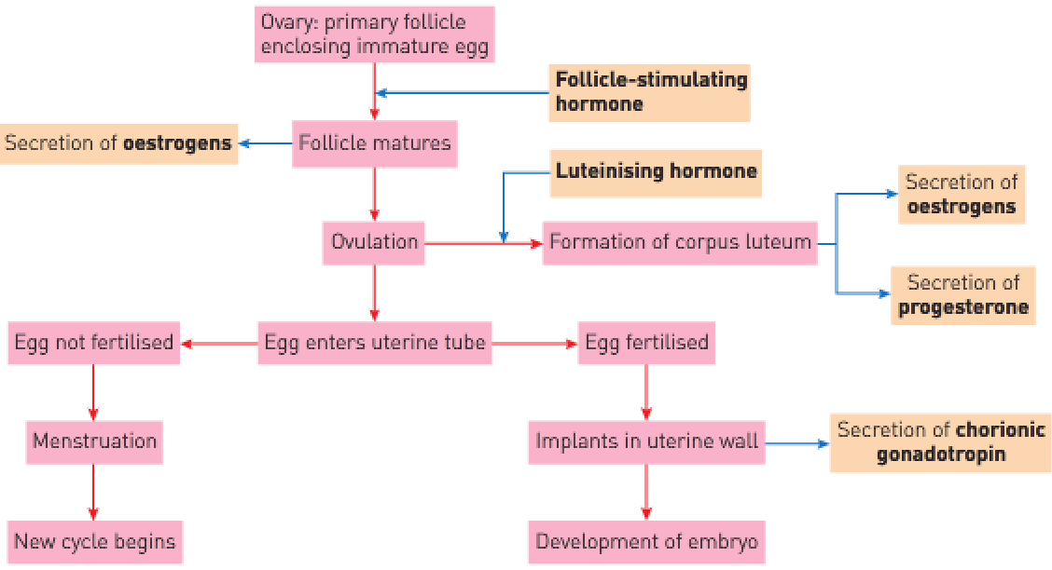
In males:
- FSH stimulates the epithelial tissue of the seminiferous tubules in the testes to produce sperm.
- LH stimulates cells in the testes to secrete testosterone which is important for the development of immature sperm cells into mature spermatozoa and has a major role in the maintenance of the male reproductive organs and sex drive.
- The production of testosterone influences the development of the body to sexual maturity. In females, the same sexual maturation is brought about by oestrogens.
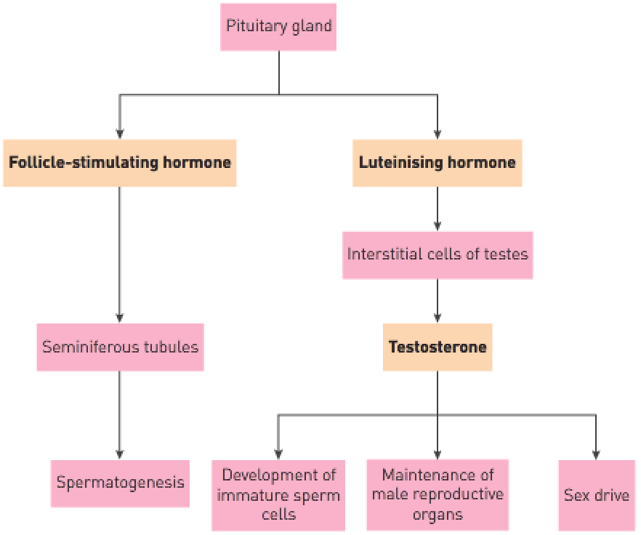
Secondary sexual characteristics:
- Secretions of sex hormones at puberty brings about the development of secondary sexual characteristics – characteristics associated with a person’s sex but not directly involved in sexual reproduction.
- Examples: Breasts, broadening of hips, growth of pelvic bones and deposition of fat for females and voice changes, distribution of added hair and pubic hair.

